**PROGRAM 1**

**Aim:**Learning about the tools and installation of various environment in python.

**Jupyter Notebook**

Project Jupyter exists to develop open-source software, open-standards, and services for interactive computing across dozens of programming languages.

The Jupyter Notebook is an open-source web application that allows you to create and share documents that contain live code, equations, visualizations and narrative text. Uses include: data cleaning and transformation, numerical simulation, statistical modeling, data visualization, machine learning, and much more.

**Functions:**

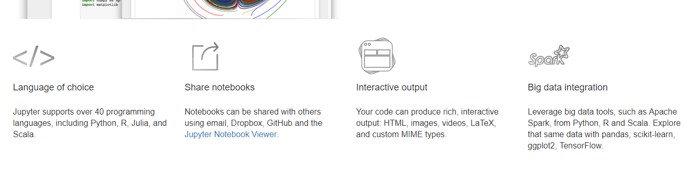



[**Installing Jupyter using Anaconda:-**](https://test-jupyter.readthedocs.io/en/latest/install.html#id3)

For new users, we **highly recommend** [installing Anaconda](https://www.continuum.io/downloads). Anaconda conveniently installs Python, the Jupyter Notebook, and other commonly used packages for scientific computing and data science.

Use the following installation steps:

* Download [Anaconda](https://www.continuum.io/downloads). We recommend downloading Anaconda’s latest Python 3 version (currently Python 3.5).
* Install the version of Anaconda which you downloaded, following the instructions on the download page.
* Once you have installed Jupyter Notebook. To run the notebook:
* Click on launch jupyter notebook after starting Anaconda